**Be ready to meet Jesus**

**Reading:** Matthew 25:31-40

The Son of Man will come in all his glory. All the angels will come with him. Then he will sit in glory on his throne. All the nations will be gathered in front of him. He will separate the people into two groups. He will be like a shepherd who separates the sheep from the goats. He will put the sheep to his right and the goats to his left.

Then the king will speak to those on his right. He will say, “My Father has blessed you. Come and take what is yours. It is the kingdom prepared for you since the world was created. I was hungry and you gave me something to eat. I was thirsty, and you gave me something to drink. I was a stranger, and you invited me in. I needed clothes, and you gave them to me. I was ill, and you took care of me. I was in prison, and you came to visit me.”

Then the people who have done what is right will answer him, “Lord, when did we see you hungry and feed you? When did we see you thirsty and give you something to drink? When did we see you as a stranger and invite you in? When did we see you needing clothes and give them to you? When did we see you ill or in prison and visit you?”

The King will reply, “Anything you did for one of the least important of these brothers and sisters of mine, you did for me.”

**Thought about the reading**

When Jesus went up to Heaven, his friends saw two angels, who told them that he would come back again one day. Jesus himself promised that he would return. No-one knows when he will return, but he will come with all the angels and everyone will see him.

He told his friends to ‘Be ready!’

How can we be ready to meet Jesus when he returns? The story today tells us what he wants us to do. He wants us to be kind and help other people, because when we do that, it is like doing it for Jesus himself. We don’t have to do big things. We can make a cup of tea for someone or visit a friend who is ill or welcome someone who is new in church or at work or at the day centre. We can all do these things.

**Prayer**

Dear Jesus, thank you for your promise to return. Please help us to be ready to meet you. Please help us to be kind to people around us and to help them when we can. Amen

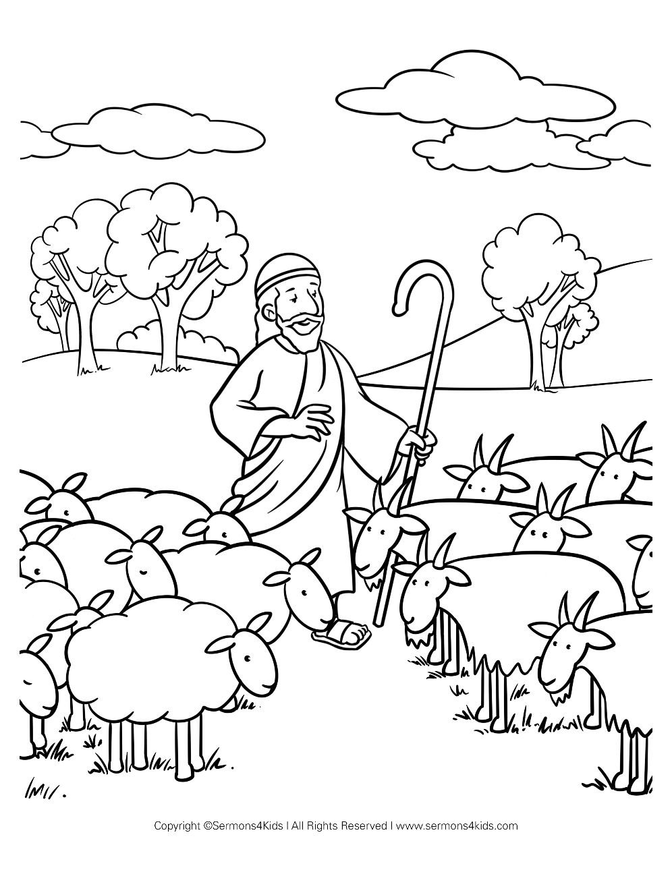

**Cambridge Causeway**

Summer 2025

Bible Study notes

**How Jesus wants me to live**

**6. Prepare to meet Jesus**

By Chrissy Cole